**Description of the KPIs and the business conclusions derived from the ShopNest Store Analysis Dashboard:**

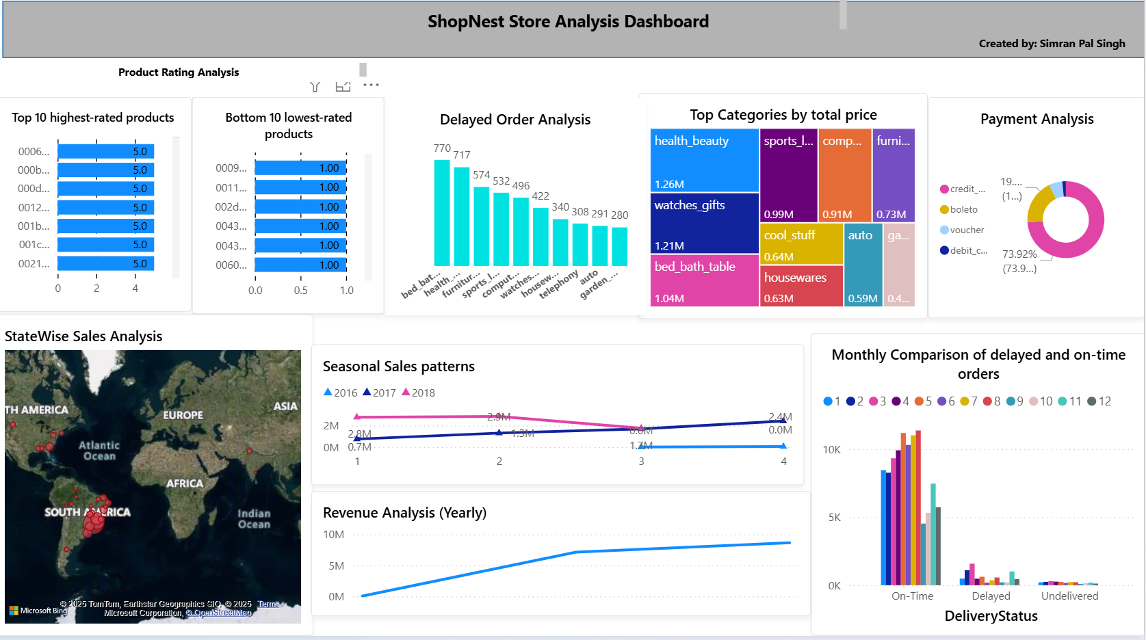

**1. Product Rating Analysis**

* **KPIs:** Average customer rating for products, segmented into the top 10 highest-rated and bottom 10 lowest-rated.
* **Conclusion & Business Action:** There is a strong polarization in product satisfaction. Several products are either loved (perfect 5.0 ratings) or hated (1.0 ratings).
* **Action:** The business should heavily **promote the top-rated products** as proven winners. For the bottom-rated products, an **immediate review** is needed to check for quality issues, misleading descriptions, or defects. Delisting these products should be considered to prevent further customer dissatisfaction.

**2. Delayed Order Analysis**

* **KPI:** Count of delayed orders, broken down by product category.
* **Conclusion & Business Action:** The "bed, bath, table" and "health, beauty" categories are the primary drivers of order delays.
* **Action:** The logistics and supply chain teams must **investigate the root cause** of delays in these specific categories. This could be due to unreliable suppliers, warehouse location issues, or problems with bulky item shipping that need to be addressed.

**3. Top Categories by Total Price**

* **KPI:** Total sales revenue (total price) per product category.
* **Conclusion & Business Action:** The store's revenue is dominated by the **"health_beauty" ($1.26M)** and **"watches gifts" ($1.21M)** categories. Other categories like "sports_leisure" and "furniture" contribute significantly, while some are minor.
* **Action:** This informs marketing and inventory strategy. The business should **double down on its top-performing categories** with targeted campaigns and ensure healthy stock levels. They can also explore cross-selling opportunities between popular categories.

**4. Payment Analysis**

* **KPI:** Percentage distribution of payment methods used by customers.
* **Conclusion & Business Action:** **Credit cards are the overwhelming payment preference (71.9%)**. Other methods like "boleto" and "vouchers" are used far less frequently.
* **Action:** Ensure the **credit card payment gateway is seamless, secure, and reliable**, as it's the most critical payment channel. The business could also simplify the checkout process by de-emphasizing less popular options.

**5. StateWise Sales Analysis**

* **KPI:** Total sales volume by geographic region.
* **Conclusion & Business Action:** The business has its strongest markets in **South America and North America**, with a smaller presence in Europe and Asia.
* **Action:** This data is crucial for allocating marketing budgets and managing regional logistics. The company can decide whether to **focus on growing its strong American markets** or develop strategies to penetrate the smaller European and Asian markets.

**6. Seasonal Sales Patterns & Yearly Revenue**

* **KPIs:** Quarterly and yearly sales revenue over time.
* **Conclusion & Business Action:** The business is experiencing **healthy year-over-year growth**. Sales are highly seasonal, with a significant peak in the fourth quarter (Q4) of each year.
* **Action:** This pattern is critical for **inventory and staffing planning**. The company must stock up and prepare marketing campaigns well ahead of Q4 to maximize holiday season revenue. They could also run promotions during slower periods like Q1 to smooth out sales.

**7. Monthly Comparison of Orders**

* **KPIs:** Monthly count of on-time vs. delayed/undelivered orders.
* **Conclusion & Business Action:** While most orders are on time, the absolute number of **delayed orders spikes during the peak sales months** (August through November).
* **Action:** The operations team needs to proactively **scale up its logistics capacity before the peak season**. Hiring temporary staff, securing more delivery partners, or optimizing warehouse workflows during these months is essential to maintain customer satisfaction when order volume is highest.